PARISH NEWS
The Deverills & Crockerton

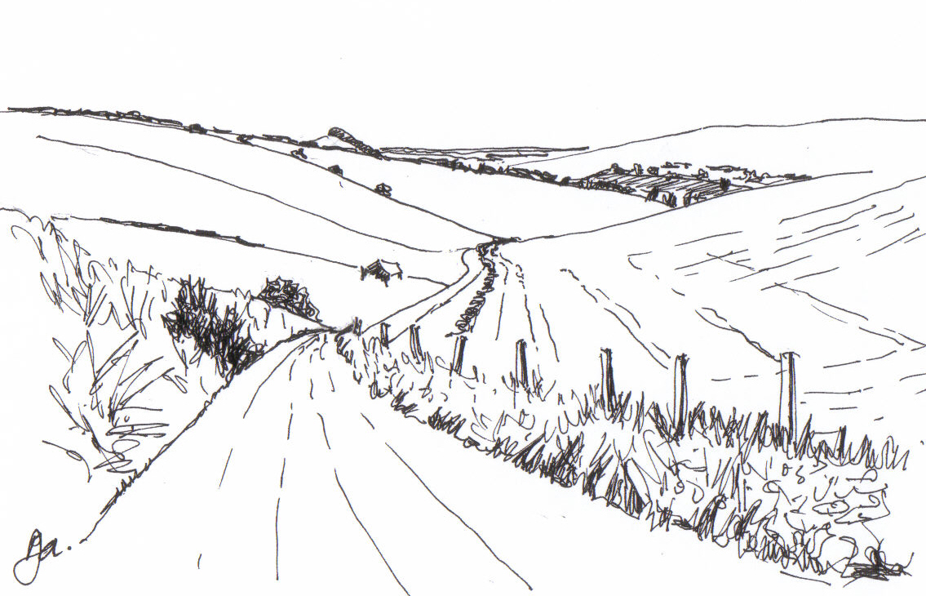

Pen Hill

Pen Hill
by Pat Armstrong

November 2009

Look inside for local information

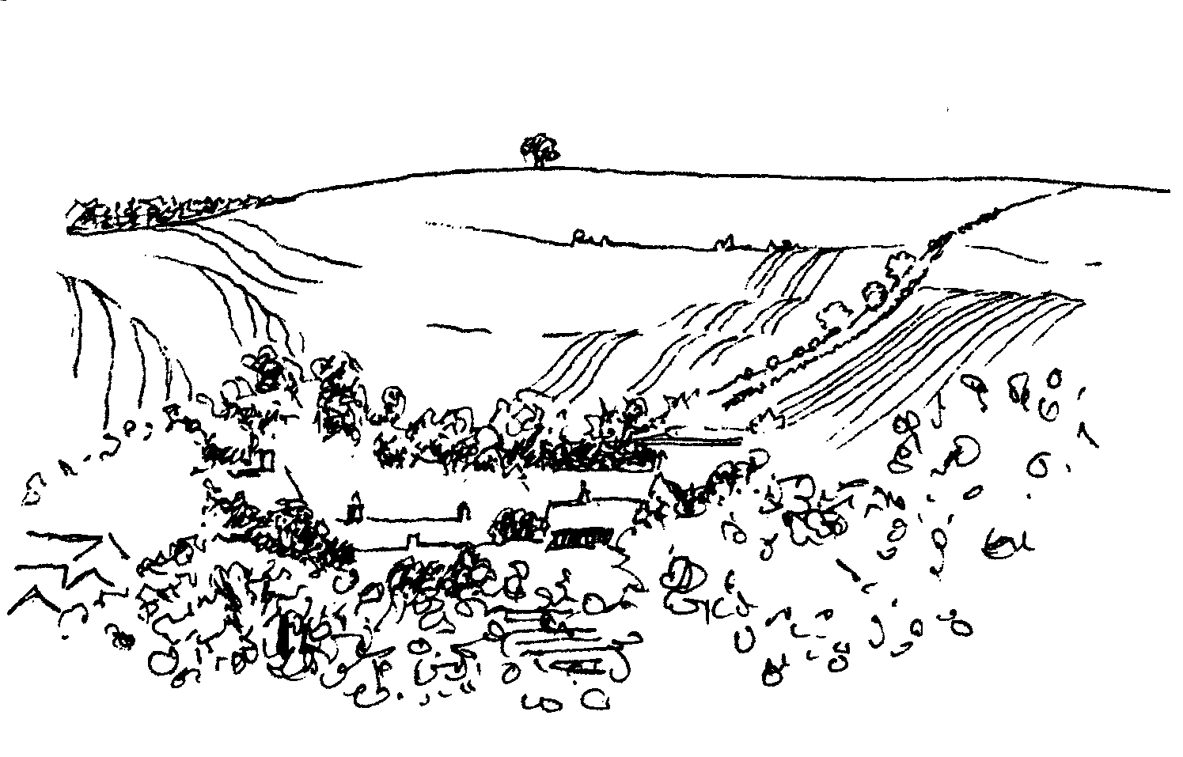

-2-

Christmas Bazaar in aid of Save the Children
Saturday 14th November 10.00 am - 3.00 pm
at Mill Farm House, Hill Deverill
Homemade produce, cards and a great variety of stalls
Coffee and light lunches available
Enjoy shopping in lovely, relaxed surroundings

Deverills Chamber Choir
Invites you to an informal concert
Friday 20th November at 7.30 pm
At Longbridge Deverill Church
Light refreshments - small donation appreciated
Come & listen to a variety of songs - you may be inspired to join us!
For more information please contact Claire Johnson 840787

CROCKERTON VILLAGE COMMITTEE
Music Quiz - Sunday 15th November
at The Bath Arms
7.00 pm, £8.50 ticket to include a main meal
£1 of each ticket kindly donated by Dean to Crockerton School
To book contact Marion – 213739, Tracey – 216939, Bernie – 218401
Please book by 5th November - Teams of four please - All Welcome

Coffee, Cards and Chat
Come and enjoy looking at the new range of cards,
ribbons, wrapping paper, and other exciting items
displayed by John and Maddie Goodden
in the Upper Deverills Village Hall on Thursday 19th February
between 10.30 and 12.00 noon - everyone is welcome
Donations will be made to the hall and the church

BULL MILL ARTS CHRISTMAS EXHIBITION & SALE
Saturday 28th and Sunday 29th November

Artists Studios are open from 10.00 am to 4.30pm
at Bull Mill Arts, Bull Lane, Crockerton

Painting, sculpture, printmaking, bookbinding and jewellery

(Tel 215628) or wvat.co.uk

-3-

The Rector writes:
As the days shorten and the commercial world sets its sights firmly on Christmas, I reflect on the past few weeks. It was wonderful to meet new people who came to join us for worship on Back-to-Church-Sunday [or a Sunday near that date]. Thank you for accepting the invitations you received.
Our Harvest Festival celebrations took place at the beginning of October, and were a very good opportunity to give thanks for all that we receive at God’s hand, and for the beauty of the areas in which we live. Our thankfulness was reflected in the generous donation of gifts for the local foodbank. Again, it was a great pleasure to welcome visitors to worship on those occasions.
Hopefully the experience for everyone, and especially for visitors, was enjoyable and worth repeating. It is really beneficial to take a little bit of time out from the hustle and bustle into which we are so easily drawn at this time of year. Coming to church can give us the opportunity to ‘be still’, and have time to think. November offers various possibilities. On 1st November we celebrate All Saints and All Souls. The latter is devoted to remembering particularly those close to us who have died during the past year or indeed years past. On 8th November, it is Remembrance Sunday, a day which seems increasingly important as we face the difficult questions about conflicts past and present. We remember those who continue to suffer and who sacrifice their lives for the freedom of others. The month ends with the festival of Christ the King on 22nd November and with Advent Sunday on 29th November. Speaking personally, Advent seems early enough to begin to think about Christmas!
If you thought about coming to join us in church, but didn’t quite make it, hopefully there will be an opportunity in the coming weeks. I am always willing to listen to comments you may have, or to answer questions. I hope that remembering the ‘come as you are’ slogan adopted for Back to Church Sunday will encourage you. Come as you are. God welcomes us as we are. We do not have to pretend to be what we are not. May God bless you all in this month of remembering.
Norma Payne
November ‘Natter’ - Living Faith
A light supper will be followed by a talk and discussion on the theme of living out our faith at work. We will meet at the Rectory from 7.00 - 9.00 pm on the following dates: Wednesday 4th, Tuesday 10th, Thursday 19th, Thursday 26th November. Please come and join in for an interesting evening.
Charity Event Friday 20th November 11.00 am - 2.00 pm
Come to Longbridge Village Hall for Coffee and a Ploughman’s lunch (in aid of Juba Secondary School), Phoenix cards and many other stalls. If you would like to book a stall please call Maddie 845318 or Norma 841321.
Bell Ringing
Have you heard the bells at Longbridge on Wednesday evenings? They are getting better every week! But we still need more ringers - preferably those who have rung before. But novices are also very welcome - after all, we were absolute beginners earlier this year! It’s great fun. Please contact Richard Munro on 844385 or richardmunro@tiscali.co.uk. We would really like to hear from you.

-4-

Save the Children
Cream Teas and Garden Open in aid of Save the Children held at Mill Farm House, Hill Deverill on the last Sunday of the month from April to September raised a total of £2,464. Anne Hurd and all those involved would like to thank Val Dale and family for their hospitality and everyone who came along and supported us.
MacMillan Biggest Coffee Morning
A big thank you from Janet Budgen and her team to all who gave raffle prizes, cakes, and other items, and who supported this event. We made a wonderful £732.
Breast Cancer
The Breast Cancer Coffee Morning held by Judith Hirons and Ann Jones raised over £300. A big thank you to everyone who came, making the event so successful.
Kampala Music School
A huge thank you to everyone who generously supported the coffee morning. Many beads and cards were sold, with coffee and cake enjoyed over a chat. A special thanks to Mrs Titt who helped me. We raised £179.80 for KMS. This goes towards a bursary to enable a Ugandan child to learn an instrument. Beads and cards are still available from me, Claire Johnson (840787).
Clarinet Quintet Concert at Longbridge Church
Those who attended the concert were privileged to listen to three beautiful pieces played most superbly by members of the quintet who all contributed to a memorable evening. Claire Johnson introduced each work and gave a summary of the clarinet’s history. Well done to all the players, and to Janet Budgen and her team who had produced a splendid three course supper in the village hall beforehand.
Guy Ratcliffe
Aspire
This charity helps to support people with spinal injuries. Tom Blood (14), Jacob Blood (11) and Alex Mitchell (15), all of Longbridge Deverill, are taking on the Channel! They are swimming the 22 miles in Warminster swimming pool - that's an incredible 1,416 lengths - to raise money for the charity and the work they do. Anyone wishing to sponsor the boys, please visit www.justgiving.com/Lynn-Blood or www.justgiving.com/Alex-Mitchell or call at 11 Church Street. They have had a fantastic response so far, raising over £1,000 so please keep donating. Thank you!
Crockerton School
We have been using the new mobile since September and it has been a huge hit! The children and staff have settled in well. I hope that you will agree that the extra space created for staff off-road parking has been successful. Year 6 children ‘cut the tape’ at the grand opening, so good that many of you came and enjoyed an evening with us. I hope you saw the reports in the Warminster Journal and Wiltshire Times.
We are looking forward to an exciting year at the school. To keep up to date with events please have a look at the website: www.crockerton.wilts.sch.uk, if you have any questions do not hesitate to contact the school or myself via the school.
Graham Dopheide Chair of Governors

-5-

Deverills Chamber Choir
The choir needs you! Do you sing in the bath, in the car or garden? Do you enjoy meeting people and are free on Friday evenings? The Deverill Chamber Choir could be for you! The choir, made up of people from the Deverills and Warminster is now 15 members strong who have been enjoying singing a variety of folksongs from Africa and the British Isles, spirituals, sacred and comic songs. (The last song usually takes place at the George!) If you are interested, come and hear us at our informal concert on Friday 20th November (see page 2), with drinks and nibbles afterwards.
The Cast on Club
Thank you to those who have come to the previous meetings. This month we will meet on Thursdays 5th & 19th November from 10.30 am - 12.30 pm at Jo Steptoe’s house, Fry Streams, 37 The Marsh, Longbridge Deverill. Everyone is welcome whether you have knitting skills or not, help will be at hand! The patterns are simple. It would be helpful if you can bring some soft baby wool and a pair of 8 or 9 needles, if you have them. We look forward to seeing you. Contact Jo 841396 for directions.
Poppy Appeal 2009
The Royal British Legion (RBL) aims continuously to improve the welfare and support provided for war veterans and their dependents of all ages. A defence source says a UK All Arms Battle Group in Afghanistan suffered over 100 casualties killed or wounded between this April and late August. This has become the order of casualties that can be expected by many other battle groups deployed into this theatre. These are lean times for members of the armed forces and their families. Those caught up in tragic outcomes can find themselves facing desperate futures and the RBL remains our leading contributor to the task of providing them with the best possible chance in future years. People have been increasingly generous in their giving over past years, may I please ask you all to be so again this year. House to house collections from 24th October until 7th November, Saturday 7th November - Poppy Day, 8th November - Remembrance Sunday, Wednesday 11th November - Armistice Day.
Robin Greenwood - Hon Organiser
Alabaré
The Wiltshire based homeless charity Alabaré has launched a new campaign providing tailored support to ex-Service men and women. Recent findings from the National Association of Probation Officers revealed a shocking 20,000 ex-Service personnel are either in prison or on probation. The charity recognised a need for support for the ex-Service community and earlier this year opened Mon Abri House (meaning my safe haven) in Plymouth, our first project for former members of the Armed Forces. Funded by The Royal British Legion, Mon Abri provides accommodation and support to men and women who are experiencing difficulty after leaving military service. Staff offer help with complex issues: Post Traumatic Stress Disorder, drug and alcohol addiction, education, employment and life skills. Demand for places is extremely high; it only has 7 beds. Alabaré would like to open 5 more homes in Hampshire, Wiltshire, Dorset, Devon and Bristol providing 35/40 more bed spaces. Alabaré needs to raise £5 million over the next 5 years. See www.alabare.co.uk.

-6-

Matinee Concert, Athenaeum Centre, Warminster (213891)
Sunday 15th November 3.00 pm
by two highly gifted, prize-winning musicians
John Paul Ekins (Piano) & Michal Cwizewicz (Violin)
Programme Bach, Schubert, Brahms, Bach/Busoni, Szymanowski
Tickets £12 & £10 (concess) – seats not numbered
For more information, please call 01985 215679 or 01373 823383

Salisbury Theatre Club Trips
Monday 16th November
Arsenic & Old Lace by Joseph Kesselring
The cost is £17.00: theatre seat £12.00 and coach trip £5.00
Booking and payment in advance to Mary Stewart Cox
Tel 840877 at Longmead, Brixton Deverill, Warminster BA12 7EJ
Coach leaves Kingston Church 6.10 pm collects through the Deverills
Performances begin at 7.30 pm

Clippers & Windjammers
Great days of square rigged sailing ships in stories and pictures
Saturday 21st November in Codford Village Hall
Doors open 6.45 pm for a glass of wine,
Performance at 7.15 pm followed by supper
Information & Tickets £15 from Jane 840258 or Annie 840184
In aid of Hope & Homes for children and
Friends of Heytesbury, Knook & Tytherington Churches
CROCKERTON VILLAGE COMMITTEE and CROCKERTON SCHOOL
Tuesday 15th December
Come and join the Children’s Carol Service Procession
Start Broadmead Lane 6.00 pm, progressing to The Bath Arms Crockerton for a grand switch on of Christmas tree lights and blessing of the
tree by Norma Payne, our Team Vicar
Carols, mulled wine and mince pies; please bring a Christmas
decoration or bird food to put on the tree. All are welcome.

-7-
Deverill Valley & Crockerton Women's Institute
The local WI was formed in November 1920, so this month marks the start of our 90th year. Are we the longest running non-sectarian organization in the valley? Every WI is what its members make it, almost anything is possible, so if you think we need to change to take us forward to our Centenary come and join us! Bring your ideas, be prepared to help carry them out, your views will count. Our evening meeting at 7.30 pm on Monday 9th November features ‘Memories of a London Traffic Warden’ by Jean Cooper. Please bring gifts for Green Lane patients. Information from Jill 840209.
Upper Deverills Village Hall
Curry Lunch - Remembrance Sunday 8th November 12.00 noon
A curry lunch, provided by the Agra restaurant in Warminster, will take place in the hall and is timed so that those attending the Remembrance Service can proceed direct to the Village Hall for a prompt and delicious curry which will be served at 12.30 pm. Tickets are £15. If you wish to attend please register with Richard Cousens (844970). Numbers will be ‘capped’ at 40, so book early to avoid disappointment. Bring your own liquid refreshment; plates, glasses and cutlery will be provided.
Quiz Night - Friday 13th November 7.30 pm
The annual Upper Deverills Quiz will take place in the hall and cost £10 per table of four. There will be a fund-raising auction for the new kitchen so bring extra cash!
‘My Life in Music’ - Talk by Martin Gatt Tuesday 17th November 7.30 pm
Martin Gatt has been principal bassoonist with London Philharmonic Orchestra, English Chamber Orchestra and London Symphony Orchestra for over 20 years. In his talk he will share his passion for music and some intriguing anecdotes from his career. Bread and cheese will be provided but bring your own liquid refreshment. Donations towards our kitchen project will be gratefully received!
Longbridge Deverill Village Hall
Our annual harvest supper was a great success this year, the evening raised over £300 which will go towards the ongoing maintenance of our hall. Thank you to everyone who attended and those who helped with this event.
Christmas Evening on Saturday 12th December
Please come and join us for an evening of carol singing and much, much more. We will be serving mulled wine and other refreshments during the interval. There will be more details about the evening in the December newsletter.
Yoga in Crockerton
Come and join our Yoga classes, beginners welcome, in the Old Pottery at Bull Mill from Tuesday 3rd November to Friday 11th December. They run as follows:
Tuesdays 7.00 - 8.30 pm, Wednesdays 9.30 - 11.00 am, Thursdays 6.30 - 8.00 pm, Fridays 10.00 - 11.30 am. Please call Daniel or Olivia on 212716.
Children’s Art Club
Pottery (for ages 6-16 years) with Vicky Whelpton at
The Old Pottery, Bull Mill on Saturday 7th November from
10.30 am - 12.30 pm or 2.00 - 4.00 pm at a cost of £7.00 per person. To book, please call 212716.

-8-
SERVICES PARISH OF DEVERILLS & HORNINGSHAM
Sunday All Saints
1st November Brixton 8.00 am Holy Communion 1662
Longbridge 10.30 am All Saints & All Souls*
Horningsham 4.00 pm All Souls Service
Sunday Remembrance
8th November Kingston 10.50 am Remembrance Service
Horningsham 10.00 am Holy Communion (said)
Horningsham 10.50 am At War Memorial
Sunday 2nd before Advent
15th November Longbridge 8.00 am Holy Communion 1662
Brixton 10.30 am Holy Communion
Sunday Christ the King
22nd November Longbridge 10.30 am Holy Communion
Horningsham 11.15 am Morning Prayer
Kingston 6.00 pm Evening Prayer
Sunday Advent
29th November Brixton 10.30 am Benefice Service
Sunday Advent 2
6th December Kingston 8.00 am Holy Communion 1662
Longbridge 10.30 am Morning Worship
Horningsham 10.00 - 12.00 noon Advent Workshop Village Hall

*We will remember and light candles for people who died in our parish this year. If you would like someone else to be remembered please give their name to the Rector.

Tuesday, Wednesday, Thursday, Friday Longbridge 8.30 am Prayers
Wednesday Longbridge 10.15 am Holy Communion

Parish Prayer Group meeting - Deverills and Horningsham
Tuesday 3rd November from 7.00 pm to 8.00 pm at Mary Royall’s house,
Sandhill Lodge, Longbridge, to pray for our communities.
Christmas cards for Sudan
These beautiful handmade cards will be on sale in our churches from Mary Royall and at Thursday Group from Barbara Beilby. The proceeds support Sudan churches.

Contact the Clergy
Please contact Norma Payne (841321) or Di Britten (01373 832515) if anyone is housebound and would like communion or a visit at home;
or if someone is ill and needs our prayers; or to discuss any church matter.
Office administrator phone 210149 or email: office@cleyhill-team.org.uk

-9-
SERVICES PARISH OF CORSLEY & CHAPMANSLADE
Sunday All Saints

1st November Corsley 9.00 am Holy Communion
Chapmanslade 3.30 pm All Souls Service
Sunday Remembrance
8th November Chapmanslade 9.00 am Holy Communion
Corsley 10.50 am Remembrance Service
Sunday 2nd before Advent
15th November Chapmanslade 9.00 am Holy Communion
Corsley 6.00 pm Prayer & Praise
Prayer Group after service
Sunday Christ the King
22nd November Temple 9.00 am Holy Communion 1662
Corsley 10.30 am Parish Service
Sunday Advent
29th November Brixton 10.30 am Benefice Service
Sunday Advent 2
6th December Corsley 9.00 am Holy Communion

Ivy House St Denys Retreat Centre (Booking & information 214824)
Thursday 12th November - CSD Gathering Day
Tuesday 17th November - House Quiet Day

Church Cleaners for November
Kingston - Mrs Beilby & Mrs Noonan
Brixton - Mrs Huntley & Mrs McDonald
Longbridge - Monday 2nd November 9:30 – 10:30 am – all helpers please
Church Flower Arrangers for February
 | Kingston | Brixton | Longbridge
1st Nov | Mrs Gatt | Mrs Greenwood | Mrs Honley
8th Nov | Mrs Mounde | Mrs Sutton | Mrs Atkinson
15th Nov | Mrs Mounde | Mrs Sutton | Mrs Atkinson
22ndNov | Mrs Joy | Mrs Hammick | Mrs Atkinson
29th Nov | Advent – No Flowers

The Deverills & Horningsham Register
Funeral at Hale, Fordingbridge
Charles Booth-Jones on Tuesday 6th October
Funeral at Longbridge
Ian Bryant on Saturday 10th October

-10-

Sir James Thynne House, Longbridge Deverill
A self-contained ground floor flat is available in this charming old building:
Bed/sitting room, small kitchen, easy access shower, use of garden area
Applicants should be aged 50 years or over and resident locally
For further information please contact Sue Jackson on 840322

Broadband Action Group (BAG) Update
Broadband in the Upper Deverills
Many readers will recall the broadband survey conducted early this year and reported on in March. It revealed evidence of very low speeds, poor reliability and cost concerns. Survey findings were passed to central government (in response to the Minister, Lord Carter’s, interim report into Digital Britain), local government, Upper Deverills Parish Council and BT at regional level. The report can be seen on www.deverills.org.uk There have been improvements since, in so far as BT have improved, by replacement, limited runs of copper wiring from Kingston to Monkton, in some cases involving tree branch cut backs (at owner’s expense). BT engineers have also spent time improving two of the worst broadband reliability cases in the valley, to test out various approaches.
Lord Carter’s final report was also published and strongly advocates a government commitment to a minimum 2 Mbps of speed to every UK household by 2012.The report also found that 89% of UK homes can get 2 Mbps now. But of the 11% that cannot, (2.75 million mostly rural homes) the reasons given are: 69% problematic home wiring, 31% random network and long wire runs to exchanges. So if you do have broadband problems why not first get your home wiring checked out? BAG are continuing to follow up the Lord Carter report. Communication is taking place with BT as regards their position and commitment to, and plans for, an investment programme. A letter will shortly be sent to the new Communications Minister, Stephen Timms MP, in which we will make the point that, as some Upper Deverills residents are being refused broadband by providers, will areas like ours be afforded priority when it comes to significant investment being implemented? We are also sounding out our local MP as to his party’s position should they be invited to form the next government.
Post Script. BT’s Regional Manager has now responded admitting that it is likely to be a considerable time before superfast broadband reaches the Deverills. He therefore feels that BAG should track progress of Broadband Enabling Technology (BET) which is now on trial in 10 pilot locations throughout the country. It is believed that this technology once funded and deployed should offer a reliable and cost effective solution to assist the Governments ambition of delivering a minimum of 2 Mbps service to virtually all UK homes. BAG will be considering this further.
Robin Greenwood

-11-

Recipe of the Month
Boiled Sausages from John Potts
The easiest way to ensure a completely cooked batch of delicious sausages which minimises kitchen odour and ensures maximum flavour. This method is particularly useful when preparing from frozen.
Ingredients: Sausages and Salt
Method: Boil a pan of salt water, prick each sausage once or twice with a fork, toss sausages into the pan, reduce heat and lightly simmer for 15 minutes.
Service suggestions: Eat them as they are with buttered toast or whatever you like, (brown them off in a frying pan first if preferred) or put them into your fridge to cool, slice later for sandwiches or grilling.
Sponsored by Maiden Bradley Community Shop (844206)
Bonfire Night - Thursday 5th November - See shop notice board for details
Where have you been?
At The Chapel, Bruton (01749 814070)
Reviewed by Judith Mirzoeff of Kingston Deverill.
It was a chance excursion in the Somerset Arts Week that led us to discover At The Chapel in Bruton. This imposing building in the High Street was once a coaching inn and more recently a Congregational chapel. After a striking conversion it has been open for a year as a restaurant, with attached shops selling bread and wine. You enter by the bakery, which has a stunning wood-fired oven heating up to bake pizza for the restaurant, and a tempting array of interesting bread, croissants, brownies and other delicious-looking cakes. The restaurant is in the main body of the chapel, now pristine white with a view across the valley through its high windows. There is a comfortable area with armchairs for breakfast, coffee, drinks and goodies from the bakery. Around the edge are the restaurant tables. The atmosphere was buzzy with a mix of young families and more sedate couples. The very reasonably-priced lunch menu is fairly simple, and we could not resist trying the pizza. It turned out to be crisp, light and well-covered and seriously challenging in size. We could have had fishcakes, burgers, steak or salad instead. The dinner menu looked more ambitious. It is a good idea to book. A modern curved staircase leads up to a balcony which provides the gallery space and an even better view. Bruton also has a deli a few doors down and some antique shops. It makes a good half-day out.
I am very grateful to Judith for writing this piece especially because, as regular readers will know, I have been spending a lot of time at RUH recently. Until the end of January, I will be having chemotherapy which will probably restrict my ability to get out and about to sample the local cuisine. I do have something for the December issue but I would be very grateful if anyone could provide some recommendations for the January and February editions.
If you have somewhere you would like to recommend, please send your comments and suggestions to me by email at farthings.kd@btinternet.com or through my letter box at Farthings, Kingston Deverill.
Trish Shuler

-12-
Warminster Rural Neighbourhood Policing Team

A new telephone scam has recently been identified. Someone claiming to be a British Telecom representative is calling residential numbers and informing occupants that they will be disconnected if an unpaid bill is not settled. For example, a caller requested a payment of £31 or it would cost £118 to reconnect at a later date. The occupant said he was with Virgin Media, the caller stated that Virgin pay BT a percentage for line rental. The caller then offered to demonstrate that he was from BT. He told the occupant to hang up and try phoning someone, and he would disconnect the phone to prevent this. When the occupant tried to call, the phone seemed to be dead. The man called back and requested a credit card payment. The 'disconnection scam' is very simple. When the occupant hangs up, the caller stays on the line with the mute button on, the occupant cannot dial out but the caller can hear the occupant trying. The person who initiates a call has to end it. When the occupant stops trying, the man cuts off and immediately calls back. This trick can appear plausible and convince the vulnerable into giving their bank details.
Neighbourhood Watch co-ordinator for Longbridge Deverill is required due to the retirement of Eric Argent, who has fulfilled this role for 12 years. If anyone is interested and would like to know more please contact me on 0845 408 7000.
Ian Owen Police Community Support Officer
Moths in Autumn
My friend, John Langmaid, had not brought his moth-trap with him when he came to stay this autumn. He said the nights were already too cold for many species to emerge. There are of course some which fly in autumn or winter, but the majority of species hibernate. Some do this in the form of moths, but most pass the winter as eggs, pupae or larvae. Of those which do emerge, several are wingless females, which most people would not recognise as moths.
Walking under our apple tree he whipped out his powerful hand lens, more like a jeweller’s than Sherlock Holmes’s, and soon noticed five different species of leaf miner. Fortunately the tree is not afflicted by the horse-chestnut leaf miner, which is causing the leaves of most of the common horse-chestnuts to turn prematurely brown. One tree we passed was infested by a million or more of this Cameraria ohridella. On emerging from the lines of eggs, their grubs had dug their way into the leaves, leaving small brown lines and patches, which appeared over the entire tree. Fortunately the damage caused by the moth does not kill the tree, though the conkers are smaller, and so, unlike the poor elms, there is no need to fell them. New leaves will grow to be infested in their turn.
This moth, which only affects the native horse-chestnuts, and ignores the type with red candles, was first observed in northern Greece in the late 1970s, and has been spreading steadily northwards since then. It has brown wings with white stripes and is only 5 mm long. That, however, is huge by comparison with the smallest British moth which mines the tiny leaves of the herb, sheep sorrel, which has a wingspan of just 3 mm, so you might be pardoned if it has escaped your notice.
Nigel Hawkins

-13-

Nature Notes
Tomorrow we are due to have our beech hedge cut. It is cut once a year in the autumn and is a mammoth task. It takes three men with petrol driven hedge cutters the best part of a day to do the job with Clive in the JCB to help them reach the bits that are inaccessible by ladders. It stands about 12 feet high, is around about 6 feet wide and 170 yards long. Clive’s father planted it in 1950 and used to cut it with hand shears listening to the tennis at Wimbledon. It was planted to shield the house from the road and certainly gives us protection from that and the weather and it is a haven for the birds. Luckily it sounds as if the weather is going to remain fine. We have been having some super days recently with lovely blue skies and hardly a breath of wind. The trees are beginning to turn gorgeous colours of orange, yellow, brown and red contrasting brilliantly with the blue sky.
I associate certain sounds with the time of the year and the screech of jays in the wood is definitely one of autumn. They are busy collecting acorns at the moment and burying them for the winter ahead. Other autumn sounds are cock pheasants calling (particularly at dusk as they settle down for the night and then again first thing in the morning on waking), tawny owls hooting at night (sometimes during the day too!) and rooks calling late evening as they go to roost in their rookery. The most evocative autumnal sound of all for me is the honking of Canada geese in the evening as they come in to roost and feed on the fields. It is often quite dark when they fly in and I have been lucky enough to see them fly across a big full deep yellow harvest moon.
Walking up under the beeches I have seen squirrels busy collecting nuts for the winter. The badgers in the lane have been changing their bedding recently or bringing in extra as the weather gets colder. There are a good number of roe deer up on the fields at the top of the farm. This afternoon I counted eight, half of which were bucks with one sporting a good set of antlers and he was showing the others that he was boss! The bees are still active in the three nests in the beeches on sunny days. So far, with it being mainly dry, there is little sign of fungi; this will soon change if the weather turns.
The birds are finding the fruits of the season. Today we had a lovely male bullfinch eating the rowan berries in the garden. There is a good crop of beech masts this year which will attract the finches. This afternoon there were lots of goldfinches in the beeches. The holly bushes are sporting a good number of berries which are slowly turning red. I wish the rest of my tomatoes would do the same!
Jane Trollope (written on 14th October)

Maiden Bradley Village Hall Christmas Fair

Friday 27th November 7.00 – 9.00 pm

Admission by raffle ticket
Mince pies & mulled wine, Tombola, Cake Stall, and lots more
Table top sale – to book a table for £10.00 ring Pam 844897

-14-

LOCAL COUNCILS, SOCIETIES, GROUPS etc.
Longbridge Deverill and Crockerton Parish Council
Karen Manfield 215526 (Chair) Peter Whithey 840347 (Vice Chair)
Helen Few 840119 (Clerk) Thomas Minter 216909
Bill Hurd 840023 Elaine Pidgeon 212878
Julian Algar 840816 Graham Read 840296
Brian Marshall 214789
Upper Deverills Parish Council
Lady Felicity Wheeler 844683 (Chair) Ranald Blue 841374
Sarah Jeffries 213436 (Clerk) Patricia Shuler 844291
Sarah Fagan 844123 Robin Greenwood 840743
Wiltshire Councillor
Fleur de Rhé Philipe 213193

Wiltshire Council 0300 456 0100

Longbridge Deverill Village Hall Committee
Julie Read 840655 (Chair) Sylvia Titt 214825 (Caretaker)

Upper Deverills Village Hall
Richard Cousens 844970 (Chair)
Mandy Martyn 844320 (Secretary) John Lea 844325 (Hall bookings)

Crockerton Millennium Committee
Marion Thomas 213739 (Chair)

Pre-School Children and Parents ‘Thursday Group’
Barbara Beilby 844995 (Chair) Sylvia Titt 214825 (Leader)

Deverill Valley & Crockerton W I
Ruth Sutton (President) Jill Russell 840209 (Secretary)

Sir James Thynne Almshouse
Mrs Sue Jackson 840322 (Steward)

Deverills Cricket Club
Jamie Fagan 844123 Peter Child 01963 34593

Wylye Valley Tennis Club
Colin Singer 213696

Wylye Valley Flower Club
Mrs Hazel Yate 215617 (President) Mrs S Scott 213689 (Programme Secretary)

Wiltshire Wildlife Trust
Elm Tree Court, Long Street, Devizes SN10 1NJ www.wiltshirewildlife.org

Rural Community Beat Manager - Police Community Support Officers
PC Vicky Pegrum - PCSOs Ian Owen & Caroline Wright - 0845 408 7000

Hospital Transport Link Scheme 211655

-15-

F O R T H C O M I N G E V E N T S
Forthcoming Events
- Scottish Dancing Monday Evenings Aline Fry (841054)
- Badminton Mondays & Fridays 3.00 - 5.00 pm Alison Rymell (844819)
- Bell Ringing at Longbridge Wednesdays 7.30 pm Richard Munro (844385)See p3
- Hearing Loss Lip-reading Wednesdays Margaret Head (213259)
- Pre-school & Parents Group Thursdays 10.00 - 11.30 am See p14
- Deverills Chamber Choir Fridays 7.30 pm Claire Johnson (840787)
- Longbridge & Crockerton Parish Council meeting 7.30 pm Monday 2nd November at Longbridge Village Hall See p14
- Yoga begins Tuesday 3rd November See p7
- Parish Prayer Group Tuesday 3rd November See p8
- November Natter 4th, 10th, 19th, 26th November See p3
- Cast on Club Thursdays 5th & 19th November See p5
- Bonfire Night Thursday 5th November See p11
- Children’s Art Club Saturday 7th November See p7
- Curry Lunch on Remembrance Sunday 8th November See p7
- Women’s Institute Evening Meeting Monday 9th November See p7
- Wylye Valley Flower Club Christmas wreaths Tuesday 10th November See p14
- Upper Deverills Parish Council meeting 7.30 pm Wednesday 11th November
Upper Deverills Village Hall See 14
- Ivy House CSD Gathering Day Thursday 12th November See p9
- Upper Deverills Quiz Night Friday 13th November See p7
- Save Children Christmas Bazaar Saturday14th November See p2
- Music Quiz Sunday 15th November See p2
- Athenaeum Concert Sunday 15th November See p6
- Salisbury Theatre Club Monday 16th November See p6
- Ivy House Quiet Day Tuesday 17th November See p9
- Talk by Martin Gatt Tuesday 17th November See p7
- Charity Event Friday 20th November See p3
- Deverills Chamber Choir Evening Friday 20th November See p2/5
- Clippers and Windjammers Saturday 21st November See p6
- Maiden Bradley Village Hall Christmas Fair Friday 27th November See p13
- Bull Mill Arts Christmas Exhibition 28th - 29th November See p2
- Upper Deverills Bingo Friday 4th December
- Longbridge Village Hall Community Carols Saturday 12th December See p7
- Carol Service Procession Tuesday 15th December See p6
- Upper Deverills Carol Service Sunday 20th December

F O R T H C O M I N G E V E N T S
16-
Contact the Editor and the Website

Parish News Editor: Judy Munro 844385
Contributions for the Parish News through my letterbox or
by post to Whitepits Lodge, Kingston Deverill, Warminster,
BA12 7HD or by Email: judymunro@tiscali.co.uk Thank you
Please remember the deadline is the 15th of every month

Website: www.deverills.org.uk
Email address: info@deverills.org.uk
Website manager: Kate Wilkinson 844998
Contents: Parish News with church services, Parish Register, Events,
Local news plus pictures and other information
PARISH OF DEVERILLS AND HORNINGSHAM
Churches
SS Peter & Paul the Apostles Longbridge Deverill
St Michael the Archangel Brixton Deverill
St Mary the Virgin Kingston Deverill
St John the Baptist Horningsham
Rector
Rev Norma Payne, 6 Homefields, Longbridge Deverill 841321
Clergy
Rev Diana Britten, 69 Lane End, Corsley 01373 832515
Licensed Lay Ministers
Mr John Budgen 218203
Col Robin Chappell 212153
Churchwardens
Mrs Elisabeth Atkinson (Longbridge Deverill) 212129
Mrs Mary Stewart Cox (Brixton Deverill) 840877
Major Mike Tulloch (Kingston Deverill) 844381
Mr Tim Moore (Horningsham) 844336
PCC Treasurer Mr David Stratton 844549
PCC Secretary Mr Nigel Poole 840902
Church Electoral Roll Officer Major Mike Tulloch 844381
Parish News Editor Mrs Judy Munro 844385
Organist Mr John Budgen 218203
Bell Tower Captain - Longbridge Mr Steven Young 212796
Caretaker - Longbridge Church Mrs Sylvia Titt 214825
Office Administrator Mr Dick Collins 210149
(Mon -Thurs 10.00 - 12.00) 22 Church Street, Warminster

